**Biotic Stresses**

**Nida Andleeb**

**Reg# 401521**

Doped CQDs alleviates detrimental effects of biotic stresses through improving nutrients uptake, hormone levels and enhancing the antioxidant defense system against pathogen attack. Phytopathogen infection is a typical biotic stress that annually causes a significant decrease in crop productivity (Li et al. 2020). For instance, CDs enhance the rice plant disease resistance ability through inducing the over expression of related genes such as thionin (Os06g32600) (Li et al. 2018). Additionally, the CQDs were also degraded into CO2 and plant hormone analogues, which then promoted the rice plant growth, while the CO2 was converted into carbohydrates through the Calvin cycle of photosynthesis (Lahiani et al. 2016).

Luo et al. (2021) reported that N-CDs (nitrogen doped carbon dots) suppressed bacterial wilt in tomatoes, statistically reduced disease severity by 71.19%. Studied showed, N-CDs were 1.56 times more effective at preventing disease than pure CDs (P-CDs). This indicates that N-CDs stimulated the anti-oxidative enzyme activity in plants, and then reduced the pathogen induced oxidative stress. Song et al. (2018) reported that the CDs extracted from cigarette smoke have antimicrobial activities, suggesting that the CDs can function as an effective broad-spectrum antibiotic, even against drug-resistant bacteria. CQDs were tested for inhibitory activity against plants (B. cinerea, A. alternata, and F. oxysporum) using optical density as an estimate for spore growth. CQDs significantly reduced mycelial growth of P. infestans and sporangia development. CQDs enhanced the dsRNA-induced gene silencing in Phytophthora infestans and to evaluate the CQDs cytotoxicity (Kostov et al. 2022). Wang et al. (2014) examined the antifungal activity of CDs against Fusarium graminearum and Fusarium poae, two significant plant pathogenic fungus. Aauthors showed that suppression of water uptake and the stimulation of plasmolysis, are two mechanisms underlying the antifungal actions of these CDs.

N-CQDs not only showed potent anti-pathogen actions but were also used for pesticide residue detection. N-CQDs exceptionally low plant toxicity was confirmed in sorghum seedlings (Wang et al. 2021). The studied demonstrated that carbon quantum dots have considerable potential as green pesticides.

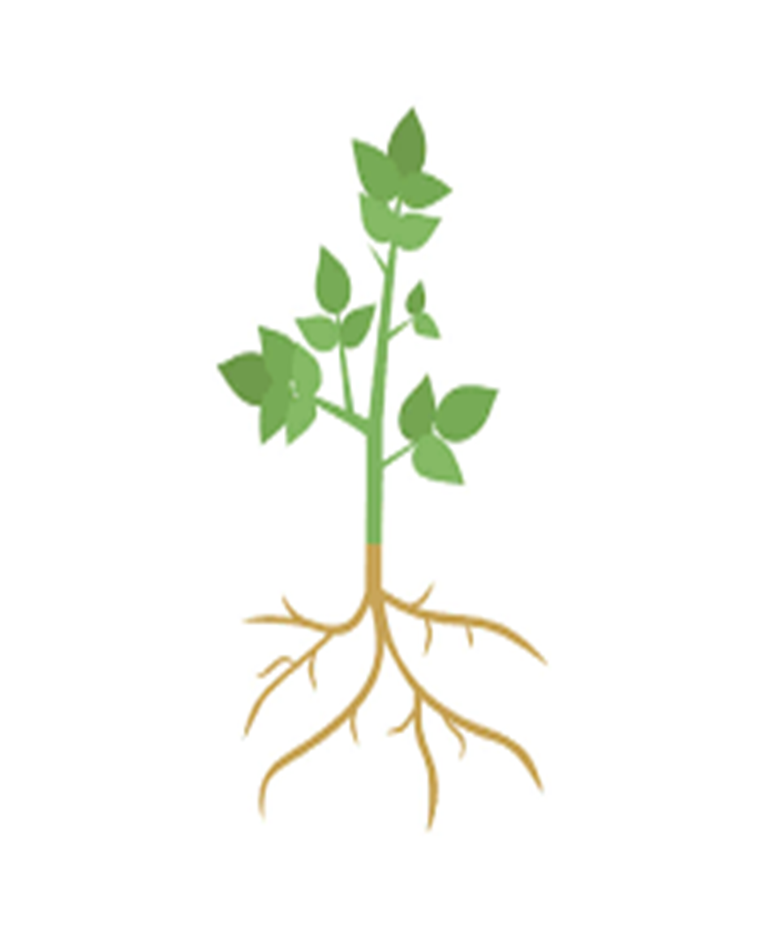

Doped CQDs exposure to plants

Induction of ROS production in plants

Activation of plant defense mechanisms

Expression of defense- related gene and enzymes

Inhibition of pathogen growth and spread

Improved Plant growth and development

Enhanced photosynthesis and nutrient uptake

Enhance the plant’s defense mechanism against biotic stresses

Regulating the gene expression in plants

Inducing the production of secondary metabolites such as phenolic, flavonoids and alkaloids

**bacteria**

**Pest**

**Fungi**

CQDs have antifungal activity against plant pathogenic fungi

Figure1. CQDs used to modulate plant growth and protect plants from stresses.

**Nutritional Significance of CQDs Coated Fertilizers**

Carbon quantum dots (CQDs) are small, fluorescent particles made from carbon atoms that have unique optical and electronic properties (Liu et al. 2020). Recently, there has been interest in using CQDs as coatings for fertilizers, which could potentially enhance the nutrient uptake of plants (Khan et al. 2022). There are some studies that suggested that CQDs can improve the nutritional value of crops. Elemike et al. (2019) reported that CQDs fertilizers are more effective than the majority of the most recent polymeric-type conventional fertilizers because of their high surface area to volume ratio. Their nature could also allow slow release and promote efficient nutrient uptake by the crops.

Dimkpa and Bindraban (2017) reported that advantages of CQDs fertilizers over conventional fertilizers include the ability to expand nutrient effectiveness, decrease the need for chemical fertilizers, increase drought and disease resistance in crops, and reduce environmental risk. Additionally, CQDs fertilizers might provide a more regulated release in order to time the nutrient flux with the crop's growth. With this approach, nutrient availability would be increased while inefficient interactions with soil or air that cause nutrient losses from the agricultural system would be reduced (Servin et al. 2015). Li et al. (2023) reported that Se-CQDs coated fertilizers could be directly absorbed by plants in terms of promoting plant biomass, mineral content, fruit quality. These advantages included the ability to be directly absorbed by plants and the ability to promote Se accumulation in the plants. While these findings are promising, more research is needed to fully understand the nutritional significance of CQD-coated fertilizers.

**Applications of CQDs in other fields**

CQDs is nontoxic and harmless green materials. It has the ability to enhance the photocatalytic effect which is recognized to its good electrical and optical properties (Si et al. 2020). Zhang and Chen (2014) reported that N-CQDs are effective as a fluorescence sensing platform for the sensitive, label-free detection of Hg2+ ions with a detection limit of 0.23 M. Ye et al. (2017) reported that CQDs-based probes have a lot of potential for food analysis, their applications for detecting food safety are not sufficiently sophisticated. CQDs are being explored as a potential material for creating intelligent nanosensors in food quality control.

Abd Rani et al. (2020) reported that CQDs have the potential to be used in the detection of heavy metal ions, removal of organic and inorganic pollutants and photocatalytic degradation of wastewater pollutants. CQDs are effective fluorescent markers for tracking drug metabolism in medication delivery systems (Badıllı et al. 2020). Recent advances in therapy-based multifunctional nano drugs and their delivery to the target organ are anticipated to have applications in the diagnosis and treatment of cancer.

**References**

1. Li, Y., Xu, X., Wu, Y., Zhuang, J., Zhang, X., Zhang, H. and Liu, Y. (2020). A review on the effects of carbon dots in plant systems. Mater. Chem. Front. 4(2), 437-448.
2. Li, H., Huang, J., Lu, F., Liu, Y., Song, Y., Sun, Y. and Kang, Z. (2018). Impacts of carbon dots on rice plants: boosting the growth and improving the disease resistance. ACS Appl. Bio Mater. 1(3), 663-672.
3. Lahiani, M. H., Dervishi, E., Ivanov, I.; Chen, J. and Khodakovskaya, M. (2016) Comparative Study of Plant Responses to Carbon-Based Nanomaterials with Different Morphologies.Nano-tech. 27(26), 265102−265115.
4. Song, Y., Lu, F., Li, H., Wang, H., Zhang, M., Liu, Y. and Kang, Z. (2018). Degradable carbon dots from cigarette smoking with broad-spectrum antimicrobial activities against drug-resistant bacteria. ACS Appl. Bio Mater. 1(6), 1871-1879.
5. Luo, X., Cao, X., Wang, C., Yue, L., Chen, X., Yang, H. and Xing, B. (2021). Nitrogen-doped carbon dots alleviate the damage from tomato bacterial wilt syndrome: systemic acquired resistance activation and reactive oxygen species scavenging. Environ. Sci. 8(12), 3806-3819.
6. Kostov, K., Andonova-Lilova, B. and Smagghe, G. (2022). Inhibitory activity of carbon quantum dots against Phytophthora infestans and fungal plant pathogens and their effect on dsRNA-induced gene silencing. Biotechnol. Biotechnol. Equip. 36(1), 949-959.
7. Wang, X., Liu, X., Chen, J., Han, H. and Yuan, Z. (2014) Evaluation and mechanism of antifungal effects of carbon nanomaterials in controlling plant fungal pathogen. Carbon. 68, 798−806.
8. Wang, Z., Liu, Q., Leng, J., Liu, H., Zhang, Y., Wang, C. and Lei, H. (2021). The green synthesis of carbon quantum dots and applications for sulcotrione detection and anti-pathogen activities. J. Saudi Chem Soc. 25(12), 101-373.
9. Liu, Y., Huang, H., Cao, W., Mao, B., Liu, Y. and Kang, Z. (2020). Advances in carbon dots: from the perspective of traditional quantum dots. Mater. Chem. Front. 4(6), 1586-1613.
10. Khan, M. A. U., Arshad, H. and Majid, A. (2022). Transport Mechanism from Quantum Dots to Plant Systems. Cham: Springer International Publishing. 103-136.
11. Elemike, E. E., Uzoh, I. M., Onwudiwe, D. C. and Babalola, O. O. (2019). The role of nanotechnology in the fortification of plant nutrients and improvement of crop production. Applied Sciences. 9(3), 499.
12. Dimkpa, C.O. and Bindraban, P.S. (2017). Nanofertilizers: New Products for the Industry? J. Agric. Food Chem. 66, 6462–6473.
13. Servin, A., Elmer, W., Mukherjee, A., De la Torre-Roche, R., Hamdi, H., White, J. C. and Dimkpa, C. (2015). A review of the use of engineered nanomaterials to suppress plant disease and enhance crop yield. Journal of Nanoparticle Research, 17, 1-21.
14. Li, J., Wang, Z., Zhang, Y., Cao, X., Lian, F. and Gu, S. (2023). Novel selenium-doped carbon quantum dots derived from algae effectively enhanced the delivery and accumulation of selenium in tomato plants (Lycopersicum esculentum) via foliar application. Environmental Science: Nano. 10(3), 866-878.
15. Si, Q. S., Guo, W. Q., Wang, H. Z., Liu, B. H. and Ren, N. Q. (2020). Carbon quantum dots-based semiconductor preparation methods, applications and mechanisms in environmental contamination. Chinese Chemical Letters. 31(10), 2556-2566.
16. Zhang, R. and Chen, W. (2014). Nitrogen-doped carbon quantum dots: facile synthesis and application as a “turn-off” fluorescent probe for detection of Hg2+ ions. Biosensors and Bioelectronics. 55, 83-90.
17. Ye, S., Huang, J., Luo, L., Fu, H., Sun, Y., Shen, Y. and Xu, Z. (2017). Preparation of Carbon Dots and Their Application in Food Analysis as Signal Probe. Chinese Journal of Analytical Chemistry. 1571-1581.
18. Abd Rani, U., Ng, L. Y., Ng, C. Y. and Mahmoudi, E. (2020). A review of carbon quantum dots and their applications in wastewater treatment. Advances in colloid and interface science. 278, 102124.
19. Badıllı, U., Mollarasouli, F., Bakirhan, N. K., Ozkan, Y. and Ozkan, S. A. (2020). Role of quantum dots in pharmaceutical and biomedical analysis, and its application in drug delivery. TrAC Trends in Analytical Chemistry. 131, 116013.